PLAN 247- Solving Urban Problems
Department of City and Regional Planning • University of North Carolina at Chapel Hill • Fall 2023
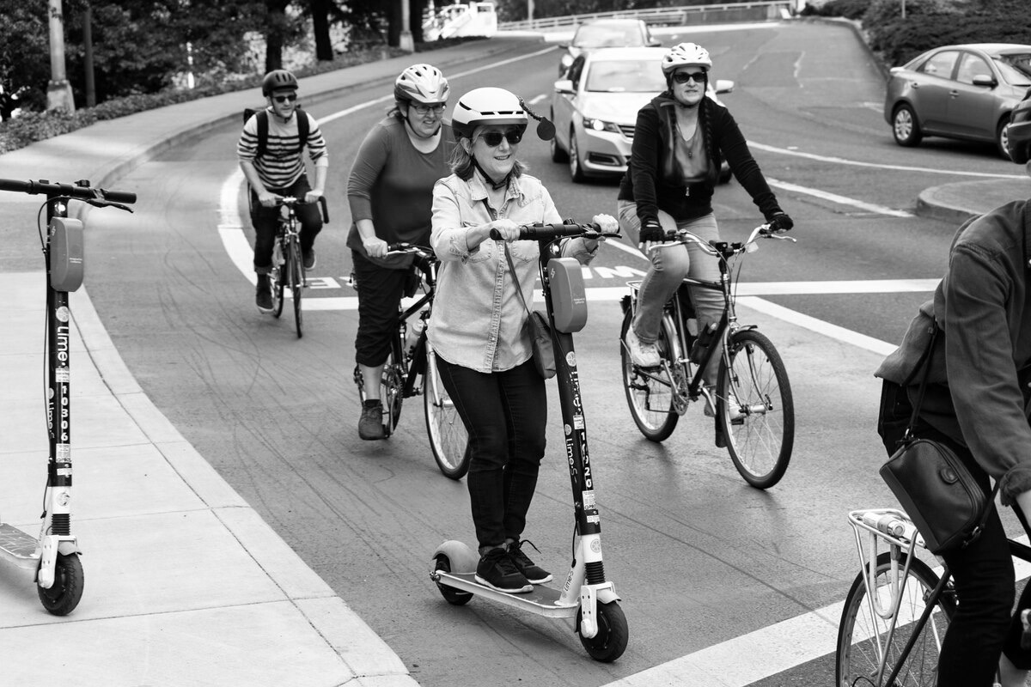
This is an introductory course on city planning. You will become familiar with the various issues and challenges planners face, stakeholders involved (e.g. local government, business owners, real estate developers, community activists, etc.), and the methods planners use to solve them.

The course is focused on one main question: How do planners solve urban problems? We’ll look at the approaches, tools, and best practices that planners use to identify and solve urban problems.

Tues/Thurs 3:30-4:45
Mitchell Rm 05
Instructor: Dr. Allie Thomas
alainna@ad.unc.edu
Office Hours
Email me to set up a time.
When we meet as a class, we will discuss how planners address problems such as affordable housing, economic development, and transportation (public transit access, new modes), taking into consideration national, regional, and local politics, climate change, and social equity issues.

Methods and tools we will use in this class include Excel, PowerPoint, data visualization (Tableau, Excel), Census data, planning documents (General Plans, zoning codes, capital improvement programs (CIPs), etc.). We will do out-of-the-class activities in small groups/pairs, such as walkability analysis and urban design analysis. You need to observe the urban environment.

This course is intended for students who want a Minor in City and Regional Planning as well as anyone who is interested in learning about urban planning. Be warned—there are a lot of acronyms in planning, but do not let that scare you off. Once you get used to them, you’ll become a planning nerd.

This course is a companion course for PLAN 246: Cities of the Future, which focuses on the history of US cities and early urban planning movements. PLAN 247 will provide a general background but will not go into significant historical detail. In other words, I may name drop and give you references to follow up on your own, but we will not spend a significant time on the history of planning.

Reusing other course materials: If you are working on a similar topic in another class, you can use the research and materials, but you cannot use the same report. For example, you can discuss climate change and planning, but it should be focused on what a city is doing to address this.

At the completion of this course, students are expected to gain the following knowledge and skills:
- Awareness of contemporary urban planning issues (persistent and emerging)
- Familiarity with the methods and techniques used to solve urban planning issues
- Ability to assess strengths and weaknesses of urban policies
- Ability to present complex information through written, oral, and visual presentations.

As a student, you are expected to:
- Complete all readings prior to class and come prepared to discuss
- Complete assignments on time.
- Ask questions in class, via email or at office hours, if you are unclear about anything.

Deadlines and exam dates are subject to change.

Assignment | % of grade
Participation | 10%
OP-ED | 15%
Planning Meeting Exercise  (due any time before Nov 16) | 10%
Response Paper | 15%
Exam 1-Take Home Exam | 10%
Exam #2 | 15%
Final Exam | 25%

Grading Scale

A | A- | B+ | B | B- | C+ | C | C- | D+ | D | F
94-100 | 90-93 | 86.50-89 | 84-86.49 | 80-83 | 76.50-79 | 74-76.49 | 70-73 | 67-69 | 60-66 | 0-59
***There is no rounding up in this class. If an actual mistake was made in the calculation of your points, let us know.

Late Assignments
Grace period: You are allowed 48 hours extra time for ONE assignment (Op-Ed, Response Paper, no questions asked.

Any other assignments that are late will be marked down 1% the first day, 2% the second day, 3% the third day and so forth. You cannot receive an “A” grade with two unexcused late assignments. You cannot receive an A if you are consistently late with assignments.

Academic Assistance
My purpose is to help you to excel in this learning environment. Should you need further assistance beyond my help, please consult the following on-campus resources:
The Writing Center: http://www.unc.edu/depts/wcweb/
Academic Success Program (for students with learning disabilities (LD) and/or attention-deficit/hyperactivity disorder (ADHD): http://www.unc.edu/depts/lds/
Learning Center: http://www.unc.edu/depts/acadserv/learn.html
Counseling and Wellness Services: http://campushealth.unc.edu

Honor code
The UNC honor Code states: “It shall be the responsibility of every student at The University of North Carolina at Chapel Hill to obey and to support the enforcement of the honor code, which prohibits lying, cheating, or stealing when these actions involve academic processes or University, student or academic personnel acting in an official capacity.” We are committed to treating Honor Code violations seriously and urge all students to become familiar with its terms set out at http://honor.unc.edu/honor/code.html If you have questions it is your responsibility to ask the professor about the Code’s application. All written work, and other projects must be submitted with a signature that you have complied with the requirements of the Honor Code in all aspects of the submitted work.

Absences
Students are permitted to miss class for EXCUSABLE absences only (for details about what an excused absence is, see UNC-Chapel Hill’s attendance policy below). If a student has unexcused absences, their attendance and participation grade will be affected. [Basically, attendance is required.] https://catalog.unc.edu/policies-procedures/attendance-grading-examination/

“For situations when an absence is not University approved (e.g., a job interview or club activity), instructors determine their own approach to missed classes and make-up assessments and assignments.”

Here’s my approach: You are allowed two unexcused absences. You must email me if you are going to be absent. You cannot make up class work when you are absent unless it is an excused absence.

Laptops and cell phones
Please turn off your cellphones before entering class. If you must have your phone on during class because of an extraordinary circumstance, please let me know beforehand.

Laptops are permissible only for classroom purposes. You must turn off all other programs including web browsers, emails, instant messaging, etc. If laptops are used for anything other than taking notes, I will ask you stop using your laptop during class time. In other words, don’t make it obvious that you are using your laptop for non-educational uses and don’t disrupt other students. If I see that it’s obvious you are not using your laptop for class, I will ask you to stop.

Disability
I have no problem accommodating anyone that has a documented need, but you are responsible for sending me the ARS letter and for finding and reserving a testing space. I will send the tests to ARS if that’s where you take the test. You can take the test on a different date or time if space is unavailable during finals. Again, just keep me informed. Don’t wait until the last minute to reserve a space, especially during Finals.

Course Requirements
The lectures will not cover all of the material in the reading, so it is essential that you keep up with the required reading. If you have any questions on the readings or if certain concepts are unclear, please let me know, you can ask during or after lecture.

Syllabus Changes
The instructor reserves the right to make changes to the syllabus, including project due dates and test dates. These changes will be announced as early as possible.

Policy on Non-Discrimination
The University is committed to providing an inclusive and welcoming environment for all members of our community and to ensuring that educational and employment decisions are based on individuals’ abilities and qualifications. Consistent with this principle and applicable laws, the University’s Policy Statement on Non-Discrimination offers access to its educational programs and activities as well as employment terms and conditions without respect to race, color, gender, national origin, age, religion, genetic information, disability, veteran’s status, sexual orientation, gender identity or gender expression. Such a policy ensures that only relevant factors are considered, and that equitable and consistent standards of conduct and performance are applied.

If you are experiencing harassment or discrimination, you can seek assistance and file a report through the Report and Response Coordinators (email reportandresponse@unc.edu or see additional contact info at safe.unc.edu) or the Equal Opportunity and Compliance Office at https://eoc.unc.edu/report-an-incident/.

Diversity Statement
I value the perspectives of individuals from all backgrounds reflecting the diversity of our students. I broadly define diversity to include race, gender identity, national origin, ethnicity, religion, social class, age, sexual orientation, political background, and physical and learning ability. I strive to make this classroom an inclusive space for all students. Please let me know if there is anything I can do to improve. I appreciate any suggestions.

Week 1 | 8/22 TU | 8/22- Overview of course.  Expectations, Assignments  Review syllabus  LA Uses Parks as Weapons—case study
 | 8/24 TH | Evolution of planning and Zoning  READ: Planning in the USA Ch 5  In class: YouTube video: City Beautiful –Introduction to Zoning, https://youtu.be/9kVWDWMcLT4  Thursday: What is Zoning? City Beautiful video YouTube: US Zoning explained: https://youtu.be/qQ7MP2e7Bqk?si=F1USJCC1YtaAlhwW
Week 3 | 9/7 TH | Legal Framework for Zoning  Relationship between State and Local Govt.  READ: Planning in the USA Chaps 6  - Comprehensive Plans and Land Use Plans Required for Zoning (North Carolina) https://canons.sog.unc.edu/2021/08/comprehensive-plans-and-land-use-plans-required-for-zoning/  - Double-Edged Sword of Preemption | Op-Ed Assignment posted  Planning Meeting posted
Week 4 | 9/12 TU | Case study: Racial and Class Bias in Zoning  READ:  - Whittemore- Racial and Class Bias in Zonings in Durham
 | 9/14 TH | All the different types of zoning techniques you could ever want to know!  READ: Chap 8 Techniques of Zoning and Subdivision regulations | In-class zoning exercise
Week 5 | 9/19 TU | Public Participation  READ:  - Arnstein’s Ladder of Participation  - IAP2 Public Participation Toolbox
 | 9/21  THU | Participatory Budgeting Exercise and Exam Review | Take Home Exam#1 posted. (Weeks 1-4)
Week 6 | 9/26  TU | Housing— Housing Policy  READ:  - “Chapter 4 History of Federal involvement in Housing policy” in Housing in America: An Introduction (2nd ed.). Routledge. https://doi-org.libproxy.lib.unc.edu/10.4324/9781003254072  - Executive Summary, pp. 1-10; and Housing Challenges, pp.39-46 in The State of the Nation Housing Report. Harvard University Joint Center for Housing Studies. pp. 1-10. https://www.jchs.harvard.edu/state-nations-housing-2023  Watch: Housing Segregation and Redlining in America: A Short History | Code Switch | NPR (6:36 minutes)  https://youtu.be/O5FBJyqfoLM?si=7A7cmwQj_-IaM_eD  In-class: https://nchousing.org/county-fact-sheets/  Find your county and download fact sheet. | Take Home Exam Due.
 | 9/28 | Housing- Externalities of our federal policies, local policies  READ: Chapter 10: State and Local Housing Policy” in Bull, M., & Gross, A. (2022). Housing in America: An Introduction (2nd ed.). Routledge. https://doi-org.libproxy.lib.unc.edu/10.4324/9781003254072  Chapter 8 Housing and the Economy”, start at Gentrification pp. 158-164in Bull, M., & Gross, A. (2022). Housing in America: An Introduction (2nd ed.). Routledge. https://doi-org.libproxy.lib.unc.edu/10.4324/9781003254072  This American Life -House Rules November 22, 2013- Listen/Read “Prologue”, Act One, Act Two (There’s a transcript and audio recording available)  https://www.thisamericanlife.org/512/house-rules  In-class: Redlining Mapping Inequality in Dayton and Springfield –  https://youtu.be/yt72OXJ8LPQ?si=GIG2JimPYsH900w7
Week 7 | 10/3  TU | Housing –  Homelessness –Who are the Homeless? What’s being done?  READ:  - NPR Radio 4 minute Listen or Transcript ‘We have nowhere to go’ https://www.npr.org/2022/08/09/1112895439/eviction-affordable-housing  - NY Times: More Than 1 in 4 American Homeowners Is 'House Poor' https://www.nytimes.com/2023/05/30/realestate/homeowners-house-poor-affordability.html  - Chapter 12: “People Experiencing Homelessness” in Bull, M., & Gross, A. (2022). Housing in America: An Introduction (2nd ed.). Routledge. https://doi-org.libproxy.lib.unc.edu/10.4324/9781003254072  - The 2022 Annual Homelessness Assessment Report to Congress (read main findings, pp2-4; first two pages of each chapter to understand the different populations, pp.10-12, 24-28, pp. 36-39,48-51, 60-63, 72-73—These are mainly tables, stats )  Supplemental: Understanding Rapid Re-housing through Participants’ Experiences –Ch. 1-5. | EXAM 1 Returned
 | 10/5 | What is infrastructure?  - READ: Planning in the USA Chapter 9-City financing and planning for development.  - The State of US Infrastructure https://www.cfr.org/backgrounder/state-us-infrastructure  - “We haven’t built for this climate” https://www.axios.com/2022/08/02/heat-wave-climate-change-us-infrastructure  - In-class: Durham, Carrboro Capital Improvement Program (CIP)—Infrastructure Budget.  In-class: Watch: Discussion --Fixing America’s Infrastructure https://www.cfr.org/event/renewing-america-fixing-americas-infrastructure
Week 8 | 10/10  TU | Infrastructure*-- Climate Change Impacts  READ:  - Planning for Infrastructure Resilience PAS Report Ch 1  - PAS-Report Planning for Heat Resilience Ch 1, 3, and 5.  Environmental Justice – watch: "Environmental Justice." Films Media Group, 2010. Films On Demand, https://fod.infobase.com/PortalPlaylists.aspx?wID=102632&xtid=276307. Accessed 27 Aug. 2023.
 | 10/12  TH | Wrap-up Infrastructure/Review for in-class exam
Week 9 | 10/17  TU | Exam #2 Public Participation to Infrastructure. In-class. | Op-Ed Draft due. Optional.
 | 10/19  THU | No Class | Fall Break
Week 10 | 10/24  TU | Transportation and Land Use  READ:  - Peter O. Muller: Ch. 3 “Transportation and Urban Form: Stages in the Spatial Evolution of the American Metropolis”, pp.56-85. In The Geography of Urban Transportation.  - Chapter 1 “Truth in Transportation Planning” in Shoup, D. (2018). Parking and the City (1st ed.). Routledge. https://doi-org.libproxy.lib.unc.edu/10.4324/9781351019668  - Ian Carlton. (2009). “Histories of Transit-Oriented Development: Perspectives on the Development of the TOD Concept.” UC Berkeley: Institute of Urban and Regional Development. Retrieved from https://escholarship.org/uc/item/7wm9t8r6
 | 10/26  THU | Transportation  - Walker, J. (2012). “What Transit Is and Does”. In: Human Transit. Island Press, Washington, DC. https://doi-org.libproxy.lib.unc.edu/10.5822/978-1-61091-174-0_1  - Walker, J. (2012). “Density Distractions.” In: Human Transit. Island Press, Washington, DC. https://doi-org.libproxy.lib.unc.edu/10.5822/978-1-61091-174-0_9  - Handy, S. “Ch 9 Making US Cities pedestrian and bicycle-Friendly” in Deakin, Elizabeth. 2020. Transportation, land use, and environmental planning. Amsterdam: Elsevier. https://search.ebscohost.com/login.aspx?direct=true&scope=site&db=nlebk&db=nlabk&AN=1789705
Week 11 | 10/31  TU | Economic Development Environment, Economic Development and Equity?  READ:  - Green Cities, Growing Cities, Just Cities?  - Flint Infrastructure short reading for Thursday in-class exercise | Response Paper Assignment posted 10/31
 | 11/2  THU | Flint Infrastructure Case Study
Week 12 | 11/7  TU | Economic Development –People vs. Place?  READ:  - Crane, R., & Manville, M. (2008). People or Place? Revisiting the Who Versus the Where of Urban Development. Land Lines.  - Brookings: REDUCING POVERTY WITHOUT COMMUNITY DISPLACEMENT,Indicators of Inclusive Prosperity in US neighborhoods, pp. 1-17.  - LISTEN: The Indicator —The Secret of Upward Mobility: Friends https://www.npr.org/transcripts/1116398427 | Return Op-Eds Drafts  Response Paper Due 11:59 pm  (Transportation-related)
Week 12 | 11/9  THU | Poverty –Myths about Poverty; Is Poverty Line still valid?  “The War on Poverty Is Over. Rich People Won.” The Atlantic  Watch: CBS- Surviving an Unlivable Wage | Full Documentary  https://youtu.be/GbvNhQ4lYLE?si=JKoE6megAsswqAWP
Week 13 | 11/14 | Community Development  READ:  Green, G. P., & Haines, A. (Eds.). (2012). Asset building & community development (3rd ed.). Thousand Oaks, Calif: SAGE. Chapter 1: The role of Assets in Community Based Development  - Food Deserts and Redlining:  - Dollar Stores squeezing out grocery stores- WATCH: https://youtu.be/I8fDRO9T3CM?si=DwKuuAjJhulZGzzo  - NPR 1A-Remaking America: The Anti-Dollar Store Movements https://the1a.org/segments/1a-remaking-america-the-anti-dollar-store-movement/  Listen to: Parts 1-3 on Dollar store growth in the South from WWNO: https://www.wwno.org/news/2023-04-06/dollar-stores-are-everywhere-in-the-south-these-5-charts-explain-whats-behind-their-growth  - Community Solutions: https://ilsr.org/community-wins-in-the-face-of-food-deserts-local-governments-and-communities-are-opening-their-own-grocery-stores/  - Institute for Local Self-Reliance: ILSR reports on strategies, etc. https://ilsr.org/dollar-stores/
Week 13 | 11/16 | Finish in-class exercise (no class)
Week 14 | 11/21  11/23 | Work Session – NO in-person class  Thanksgiving | Changed: 11/21 Op-Ed Final Draft due
Week 15 | 11/28 | CASE STUDIES/IN-CLASS EXERCISE | Response Papers returned.
 | 11/30 | CASE STUDIES/IN-CLASS EXERCISE
Week 16 | 12/5 | LAST DAY OF CLASS-- REVIEW
FINAL EXAM DECEMBER 9TH SATURDAY 4PM

