University of North Carolina at Chapel Hill
Department of City and Regional Planning
PLAN 591 Advanced GIS for Urban Planners

Fall 2021
3:00pm-5:30pm
New East Lab
Course Instructors, Contact Information and Office Hour Zoom Meetings:

Professor: Yan Song; ys@email.unc.edu; Office Hours: Wed 3:00-4:00pm or by appointment (Zoom https://unc.zoom.us/j/92897544138); or anytime through Microsoft Teams for more responsive Q&A through chats.

Tech Support: Yang Yang, yangyang@unc.edu; Help Hours: Thur 3:45-4:45pm through Zoom https://unc.zoom.us/j/92897544138

Course Learning Objectives:

No matter how large or small your community, planners, environmental scientists, public health officers, and other local analysts must deal with spatial information: addresses, land parcels and land cover, zoning, transportation networks, housing stock, neighborhoods, streams, and natural hazards. Federal, regional, state, county, and local planning agencies and private enterprises have realized the power of Geographic Information System (GIS) to identify problems, respond to them efficiently, and share the results with a variety of audience. GIS techniques provide tools to help you present and analyze spatial information.

This class covers a range of intermediate to advanced concepts of GIS and spatial analysis. The course intends to provide broad coverage of GIS topics so that students will feel comfortable with the most common functions of GIS and spatial analysis, and will also be competent in using GIS software. The class is not intended to make students into GIS coding, spatial modeling or spatial statistics experts – those interested in a GIS-based career path should continue to take a programming course in Computer Science, a database course in Computer Science, and one of Geography's advanced GIS offerings.

The class will be divided into lecture and laboratory components which cover both theory and practice of topics of interest. By the end of the class all students should be very familiar with almost all of ArcGIS's core functionalities. We will use both ArcGIS Desktop 10.X and ArcGIS Pro, various extensions including Spatial Analyst, 3D Analyst, Geostatistical Analyst, Network Analyst, and a variety of smaller 3rd party extensions. This course also looks at how to make GIS useful to urban planners - this means that a large part of the class focuses on the tasks that urban planners will face in general.

To achieve the above mentioned objectives, we will use the following course materials for our lab exercises and these will be provided for you.
Book forthcoming: Y. Song, Y. Yang, and Y. Ye. GIS for Planners.

Lecture ppts, the textbook with lab instructions and additional readings are provided on Sakai every week by Friday evening. Lab instructions will be provided throughout the semester.

Course Topics and Reference Readings:

Week 1 (Aug 19) - Course Overview, Get Prepared and Introduction to GIS
Lecture:
- Course overview
- How to obtain and install ArcGIS
- Application of GIS in urban planning
- Installation of ArcGIS Desktop or Pro
- Defining GIS
Reference Readings on GIS and Applications:
Esri. GIS Best Practices: GIS for Urban and Regional Planning. https://www.esri.com/library/brochures/pdfs/gis-sols-for-urban-planning.pdf

Week 2 (Aug 26) - Mapping
Lecture:
- Map design - Making effective thematic maps; Presenting data
Reference Reading on Map Design:
Esri. Introduction to Map Design.
https://www.esri.com/arcgis-blog/products/product/uncategorized/map-design-101/
Lab Session:
- Lab 1: Mapping single-family parcels in Washington County, Oregon. Chapter 2.
- Lab 2: Online mapping. Instructions will be provided on Sakai.

Week 3 (Sep 2) - Introduction to ArcGIS
Lecture:
- The basics of applied GIS – Using ArcMap, ArcCatalog and ArcToolBox
- More discussion on Map design - Map scale, Projections, Coordinate systems, and Symbols
- Making sense of Census data
Reference Reading on GIS data:
For more on downloading GIS data from Census, USGS, Google Earth and other sources, please see
https://gisgeography.com/best-free-gis-data-sources-raster-vector/
https://www.socialexplorer.com/product-data?gclid=EAIaIQobChMIiruBqoeO5AIVFJSzCh21YQzEEAAYASAAEgIg0vD_BwE
https://www.usgs.gov/core-science-systems/ngp/tnm-delivery/gis-data-download
https://github.com/CenterForSpatialResearch/gis_tutorials/blob/master/19_Importing_and_Exporting_GIS_Data_from_Google_Earth_and_Google_Maps.md

Lab Session:
- Lab 1: Preparing GIS Data – Projection. Chapter 2_supplementary.
- Lab 2: Preparing GIS Data –
  - Creating Spatial Vector Data from Other Sources, Chapter 3;
  - Georeferencing Aerial Photos, Chapter 4;
  - Geocoding, Chapter 6.
- Assignment 1 – Making sense of Census assigned. Chapter 7.

Week 4 (Sep 9) – Spatial Data Representation

*** Project 1 Discussed ***
Lecture:
- Spatial data representations: vector, raster, and surface
- Spatial data models: shapes, coverages, geodatabases, and grids
Lab Session:
- Lab 1: Geoprocessing, Dissolve and Buffer (Census and TAZ overlaying). Chapter 5.
- Lab 2: Application of Geoprocessing: Mapping job and housing balance. Chapter 8.
Reference Reading on Job-housing Balance:
Esri. http://proceedings.esri.com/library/userconf/proc16/papers/221_246.pdf

Week 5 (Sep 16) – Raster and TIN models
Lecture:
- Types of raster data; Raster data model; Raster analysis; Raster formats and Internet resources
- Application and examples of raster data model
- Surface modeling; Structure of TIN; Modeling surface feature; Surface analysis; TIN Internet resources
- Applications and examples of surface model
Lab Session:
- Lab 1: Working with DEM data – Construction topography information. Chapter 13.
- Lab 2: Working with DEM data – Hydrological analysis. Chapter 14.
- Assignment 2 – Computing the NDVI assigned. Chapter 15.
Reference Reading on NDVI:
- Mahesh Rao, Guoliang Fan, Johnson Thomas, Ginto Cherian, Varun Chudiwale, Muheeb Awawdeh, A web-based GIS Decision Support System for managing and planning USDA's Conservation Reserve Program (CRP), Environmental Modelling & Software, Volume 22, Issue 9, September 2007, Pages 1270-1280, (http://www.sciencedirect.com/science/article/pii/S1364815206001988)

Week 6 (Sep 23) – ArcGIS Extensions (1) – 3D Analysis
Lecture:
- More on Data preparation and integration; Data media conversion – digitizing; Data format conversion
- Global positioning system
Lab Session:
- Assignment 3 – Managing 3D data assigned. Chapter 12.
Reference Reading on 3D GIS and Planning:
- Bhattarai, Keshav, and Dennis Conway. "Urban Vulnerabilities in the Kathmandu Valley, Nepal: Visualizations of Human/Hazard Interactions." J. Geographic Information System 2.2 (2010): 63-84.
- Preparation of Project 1

ArcGIS Extensions (2) – Networks in GIS
Lecture:
- Concept of networks, Network models; Network analysis
- Important applications, utilities and transportation, using network model in GIS
Lab Session:
- Assignment 4 – Network analysis assigned. Chapter 9.
Reference Readings on Network Analyst and Applications:
- Greg Rybarczyk, Changshan Wu, Bicycle facility planning using GIS and multi-criteria decision analysis, Applied Geography, Volume 30, Issue 2, April 2010, Pages 282-293, (http://www.sciencedirect.com/science/article/pii/S0143622809000502)
- Belinda Gallardo, M. Paz Errea, and David C. Aldridge. Application of bioclimatic models coupled with network analysis for risk assessment of the killer shrimp, Dikerogammarus villosus, in Great Britain. Biological Invasions, June 2012, Volume 14, Issue 6, pp 1265-1278. (http://link.springer.com/article/10.1007/s10530-011-0154-0#)
Week 7 (Sep 30) –ArcGIS Extensions (3) – Spatial Analyst
Lecture:
- Spatial analysis
Lab Session:
- Lab 1: Spatial Analyst – Viewshed analysis. Chapter 16.
Reference Reading on Spatial Analyst and Applications:
- Susanna T.Y. Tong, Wenli Chen, Modeling the relationship between land use and surface water quality, Journal of Environmental Management, Volume 66, Issue 4, December 2002, Pages 377-393, ISSN 0301-4797, (http://www.sciencedirect.com/science/article/pii/S0301479702905931)

Week 8 (Oct 7) –GIS Planning Supporting Systems (PSS) and GIS Applications in City Planning
Recommended Readings:
- Brail, Richard K., & Richard E. Klosterman (Eds.). 2000. Planning Support Systems – Integrating Geographic Information Systems, Models, and Visualization Tools. Redlands, CA: ESRI Press.
- Lewis D. Hopkins. Planning support systems for cities and regions. International Journal of Geographical Information Science, Vol. 25, 2011, Issue 2. (http://www.tandfonline.com/doi/abs/10.1080/13658810903569606?journalCode=tgis20#.UhD_2STD-AV)
- Christopher J. Pettit, Richard E. Klosterman, Marcos Nino-Ruiz, Ivo Widjaja, Patrizia Russo, Martin Tomko, Richard Sinnott, and Robert Stimson. The Online What if? Planning Support System. Lecture Notes in Geoinformation and Cartography, Volume 195, 2013, pp 349-362. (http://link.springer.com/chapter/10.1007/978-3-642-37533-0_20)

Week 9 (Oct 14) - Spatial Statistics
Lecture:
- Spatial statistics
- Spatial autocorrelation; Spatial error
- Exploratory spatial data analysis
Lab Session:
- Lab 1: ArcGIS Extension Geostatistical Analyst – Air quality surface.
- Assignment 5: Geostatistical Analyst – Temperature surface assigned. Chapter 17.
Reference Reading on Spatial Statistics:
- Luc Anselin, From SpaceStat to CyberGIS: Twenty Years of Spatial Data Analysis Software. International Regional Science Review, April 2012, Issue 35, pp. 131-157. (http://irx.sagepub.com/content/35/2/131.short)
- Yan Song, Louis Merlin and Daniel Rodriguez, The Measurement of Land Use Mix: A Review and Simulation. Computers, Environment and Urban Systems.

Oct 21 Fall Break – No Class

Week 10 (Oct 28) – Advanced Data Modeling, Feature and Feature Cataloguing
Lecture:
- Progress of spatial data models
  - CAD (Computer Aided Design) data model; Georelational data model; Object-oriented data model
- Features in an object-oriented data model
- Building data models
  - Logical data model; Physical data model
- The characteristics of features; Geometry and features
- The structure of features and objects in ArcInfo 9: Subtype; Validation and domain; Relationships
- Testing spatial relationship; Topological operators
- Needs for feature cataloguing
- Understanding feature cataloguing methodology
Lab Session:
- Lab 1: Creating a geodatabase based on a logical model
Reference Reading on Geodatabase:
- Stefano Morelli, Samuele Segoni, Goffredo Manzo, Leonardo Ermini, Filippo Catani, Urban planning, flood risk and public policy: The case of the Arno River, Firenze, Italy, Applied Geography, Volume 34, May 2012, Pages 205-218, (http://www.sciencedirect.com/science/article/pii/S0143622811002232)

Week 11 (Nov 4) –ArcGIS Pro and Applications of Big Data in Urban Analysis
Lecture:
- Big data and applications
Lab Session:
- Lab 1: Point pattern analysis of social network data in ArcGIS Pro
- Assignment 6 – Scraping and analyzing spatial data via APIs in R assigned.

Week 12 (Nov 11) –Remote Sensing
Lecture:
- Application of remote sensing in planning, for example, land use and land cover analysis, and urban sprawl studies
- Basic concepts in satellite remote sensing
Lab Session:
- Lab 1: Working with Remote Sensing Imagery. Chapter 11.
- Lab 2: Estimating urban economic activities with Nighttime Images. Chapter 10.
Reference Reading on Remote Sensing and Applications:
- Qihao Weng, Remote sensing of impervious surfaces in the urban areas: Requirements, methods, and trends, Remote Sensing of Environment, Volume 117, 15 February 2012, Pages 34-49, (http://www.sciencedirect.com/science/article/pii/S0034425711002811)

Week 13 (Nov 18) –Final Project Presentations

Nov 25 Thanksgiving Break – No Class

Dec 1 Class End

Grading:

The course is structured around a series of small assignments and two related larger projects. The grade breakdown is shown below:
* Preparation of all lab reflection notes for each week (8%); Note that the reflection notes are due by Wednesday 11:59pm the following week.
* Seven Individual Assignments (each 8%) due by Wednesday 11:59pm the following week.
* Project 1 (11%); Project 2 (25%); Project 1 is on the research of several Planning Supporting Systems and other GIS applications in planning or related fields and should serve for Project 2, which is on your own design of a GIS project in planning or related field.

Instructions on all labs and projects and associated grading criteria will be provided all through the semester.

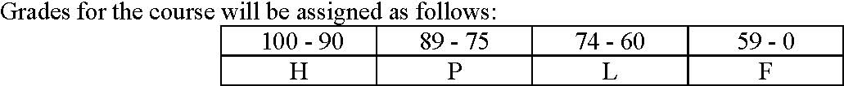

Late assignments will not ordinarily be accepted. Grades of incomplete may be given in the event of a medical or other emergency. An application for an incomplete on any assignment, including the term project, must state the reasons for the request and propose a new deadline. A grade of F will be assigned for presentations and written assignments not completed on time.

The University's Honor Code is in effect. Please consult with the instructor if you are uncertain about your responsibilities under that code with respect to this course. It will apply particularly for written work.

Instructions on Access to New East Computer Lab for Using ArcGIS:
If you are a Mac user or if your PC is slow when running ArcGIS, there are multiple alternatives for you to choose. For examples, you can use UNC Virtual Lab (https://virtuallab.unc.edu/vpn/index.html) or install bootcamp on your Mac. Furthermore, you can also reserve a computer from our own New East lab (we recommend this option, as new machines are faster and more convenient!)
Before remotely connecting, you will need to reserve a computer to connect to. To reserve a computer, go to www.go.unc.edu/neweastlab (https://outlook.office365.com/owa/calendar/DCRPComputerReserve@admin.live.unc.edu/bookings/). Select the duration you would like to use the computer (1-4 hours) and the date/time. Then select the computer you would like to remotely connect to (if available) in the Staff dropdown menu. If you select ‘Anyone’ in the dropdown menu, you will be randomly assigned a computer and you will receive an email with the computer name that you have been assigned. Please note the computer name as you will need this in order to remotely connect. For this walkthrough, I will be using computer CAS-CR-MJ0B3FK1.

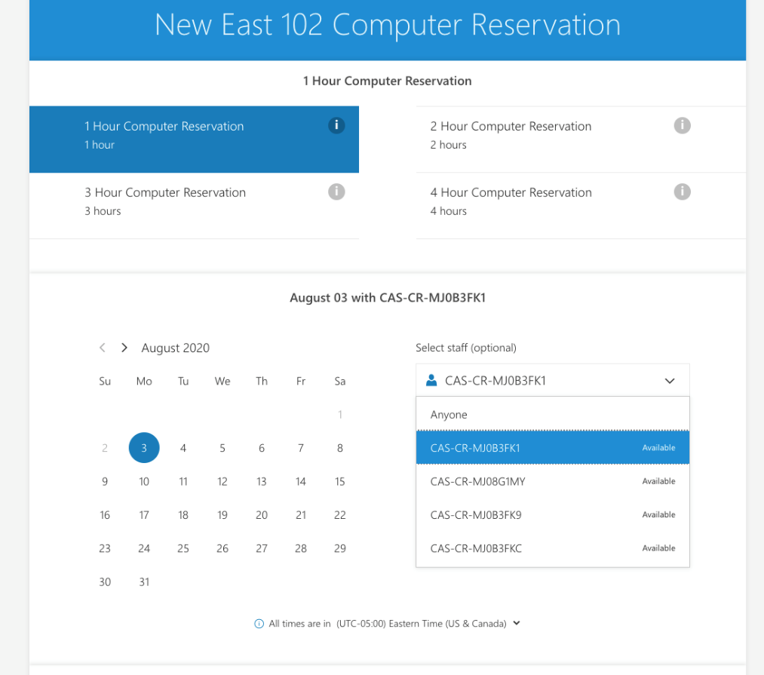

After you made a reservation,

For PC User: (Mac User Click Here)
1). In order to remotely connect, you must first connect to UNC’s VPN (CLICK HERE for more info). Once connected to VPN, on your PC, open Remote Desktop Connection (you should be able to click your start menu and type ‘remote’ to pull up the app itself). In the Computer field, input the computer name followed by the suffix .dchp.unc.edu (e.g. CAS-CR-MJ0B3FK1.dhcp.unc.edu). Then click the ‘Show Options’ button.
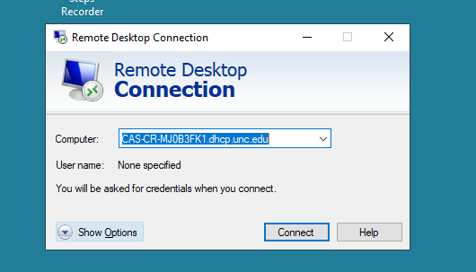

3). Input {your-onyen}@ad.unc.edu in the User name field (e.g. coxjm@ad.unc.edu) and click Connect
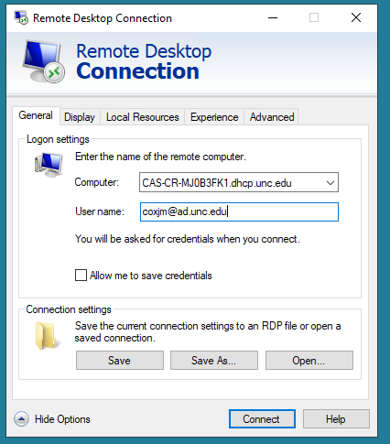

4). If prompted with this trust prompt, check the box next to ‘Don’t ask me again…’ and click Connect
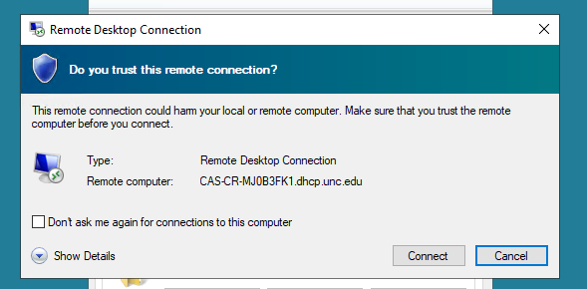
5). When prompted, enter your Onyen password and click Ok
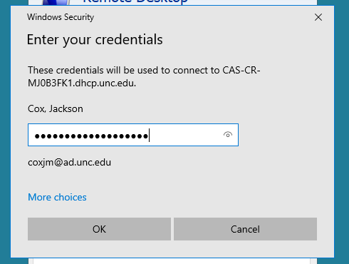
6). If/when prompted for certificate trust, check the box next to ‘Don’t ask me again…’ then click the Yes button. You should now be remotely connected and see the desktop of the lab machine.
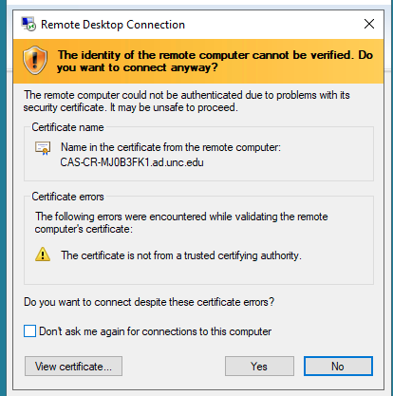

For Mac User:
1). In order to remotely connect, you must first connect to UNC’s VPN (CLICK HERE for more info). Once connected to VPN, on your Mac, open the Microsoft Remote Desktop app (the Microsoft Remote Desktop app is free and available in the App store if not already installed). Click the ‘+’ drop down menu and select Add PC
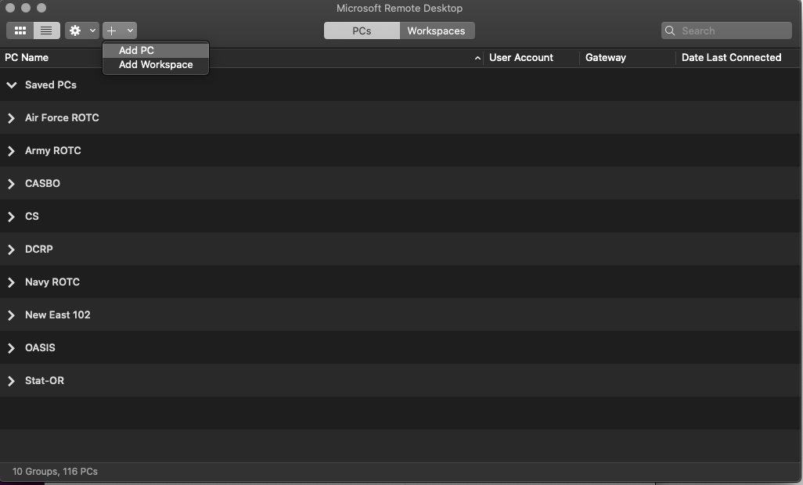

2). Input the computer name followed by the suffix .dchp.unc.edu in the PC name field and click Add
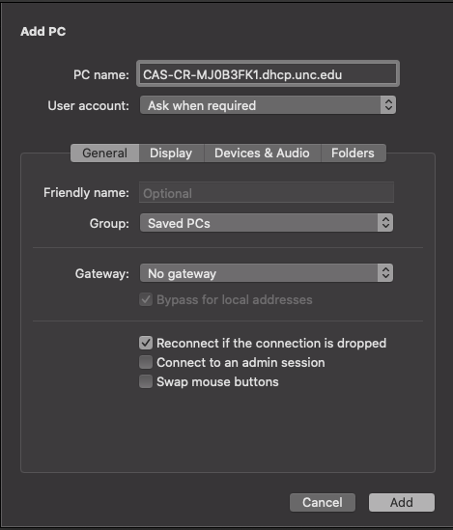
3). The computer will now show up in the Saved PCs section. Double-click to initiate the remote session
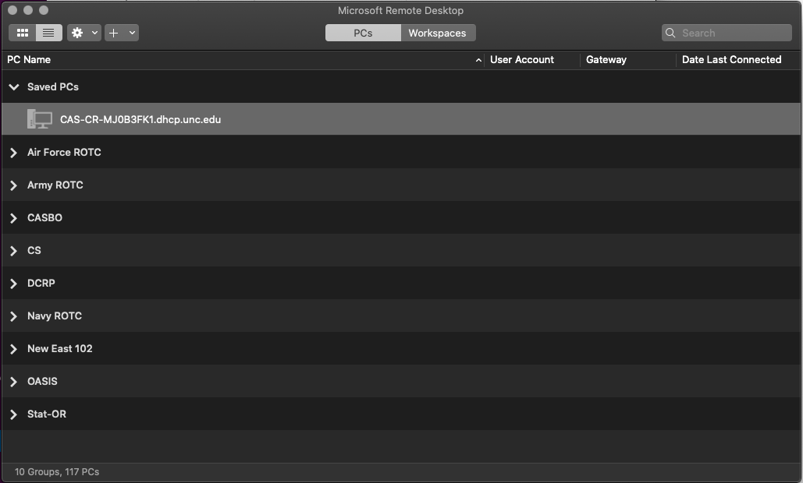

4). If prompted to trust certificate, click Show Certificate, then check the box next to “Always trust…”, click Continue and enter your PERSONAL COMPUTER password and click Update Settings (see next 3 screenshots)

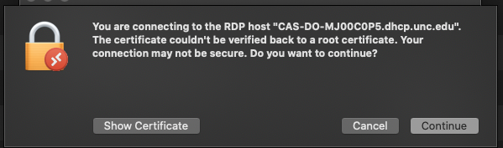

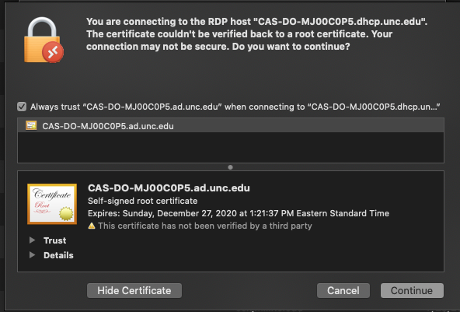

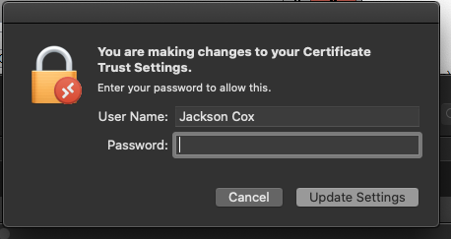

5). Input {your-onyen}@ad.unc.edu (e.g.coxjm@ad.unc.edu), your Onyen password and click Continue. You should now be remotely connected and see the desktop of the lab machine.
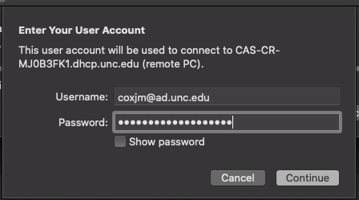

OTHER INFORMATION: Taking ESRI Virtual Campus Courses

Virtual Campus is ESRI's on-line training center. Virtual Campus offers many training courses centered on learning GIS and using ESRI's GIS software packages, which you may want to take to supplement or expand on your GIS experience from this course. For more information, explore the Virtual Campus:
http://campus.esri.com

While the majority of the courses have an enrollment fee (typically $100), creating a member account is free, and there are several intro modules that can be taken free of charge. As part of the University Site License program, ESRI allows UNC unlimited access to seats at the ESRI Virtual Campus. This does not, however, apply to every course offered at the virtual campus. To see which courses are available free and how you can take them, see:

http://its.unc.edu/gis/virtual_campus/

OTHER INFORMATION: GIS LINKS

- National Spatial Data Infrastructure (NSDI)
http://www.fgdc.gov
http://nsdi.usgs.gov/
http://fgdclearhs.er.usgs.gov/ (FGDC Clearinghouse Referral Server)
http://www.its.nbs.gov/nbs/meta/meta.html (Metadata Standard)
http://www.fgdc.gov/framework/overview.html (NSDI Framework Initiative)

- Databases - National
http://www.census.gov/geo/www/tiger/
ftp://ftp.census.gov/pub/tiger/boundary/
http://www.wessex.com/
http://www.etak.com/

- Digital Line Graph (DLG)
http://edcwww.cr.usgs.gov/nsdi/gendlg.htm

- Digital Elevation Model (DEM)
http://edcwww.cr.usgs.gov/nsdi/gendem.htm

- Digital Orthophoto Quads (DOQ); Digital aerial photography - rectified
http://nsdi.usgs.gov/nsdi/products/doq.html
http://mapping.usgs.gov/www/ti/DOQ/doqta.html
http://ortho.mit.edu

- Digital Raster Graphics (DRG); Digital 7.5 minute maps
http://mapping.usgs.gov/nsdi/html/drg.html

- Land Use/Land Cover - Bureau of Land Management
http://edcwww.cr.usgs.gov/nsdi/digital2.htm
http://www.coresw.com/Databases/ (ImageNet Remote Sensing Data Info)
http://www.gislinx.com
http://www.esri.com/base/data/catalog/abk/abksam1.html (New Hampshire)
http://plue.sedac.ciesin.org/plue/ddcarto (Census data in ArcInfo, MapInfo and Atlas GIS format)
http://www.cast.uark.edu/local/hunt/index.html (US Geospatial Data and Attributes)
http://www.epa.gov/docs/grd/forest_inventory/ (Forest Land Distribution Data from EPA)
http://www.lib.virginia.edu/socsci/collections.html (University of Virginia Social Science Data Center)
http://www.ispa.fsu.edu/labins.html (Land Boundary Information System)
http://nsdi.usgs.gov/nsdi/ (US government data)
http://edcwww.cr.usgs.gov/webglis (USGS Global Land Information System)

- Data - International
http://edcwww.cr.usgs.gov/webglis (USGS Global Land Information System)
http://ilm425.nlh.no/gis/dcw/dcw.html (Digital Chart of the World and Data Quality Project)
http://www.grida.no/prog/global/cgiar/htmls/data.htm (UNEP/GRID - CGIAR Cooperation - Datasets)
http://www.gcdis.usgcrp.gov/ (Global Change Data and Information System)
http://res.agr.ca/CANSIS/_overview.html (Canadian Soil Information System)
http://www.grida.no/prog/polar/aedea/ (Arctic Environmental Database for Europe and Asia)
http://ssda.anu.edu.au/ssda/about-ssda-holdings.html (Social Science Data Archives - Australia)
http://www.lib.berkeley.edu/ENVI/cityintl.html#data (International Data and Statistics Sources)
http://ellesmere.ccm.emr.ca/naismap/naismap.html (National Map Atlas Information Servce - Canada)

