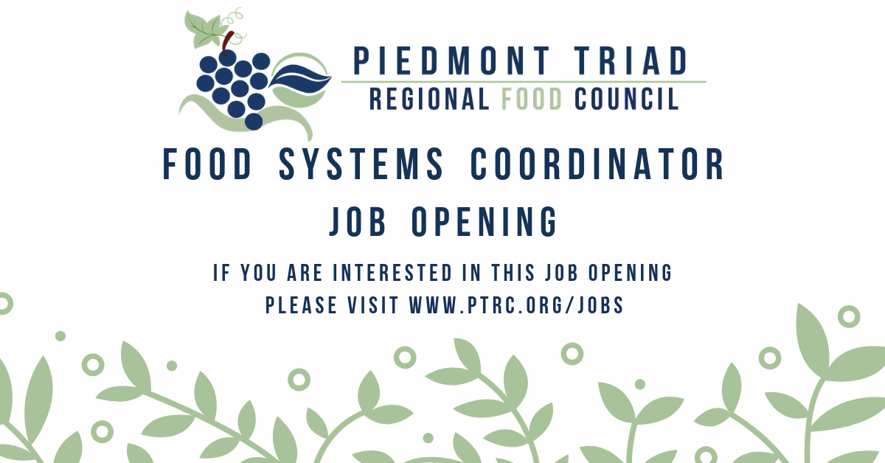

Food Systems Coordinator Position
Piedmont Triad Regional Council

Advertise Date: October 18, 2019
JOB DESCRIPTION:
The Piedmont Triad Regional Food Council (PTRFC) seeks a talented, dynamic and self-motivated Food Systems Coordinator to foster collaboration among regional council members and other stakeholders, and to direct activities promoting a healthier and community-based food system. The Coordinator will be a part of an innovative team of staff and partner organizations working to re-think how the region grows, distributes and accesses food. This position will be housed in the Regional Planning Department.

Primary responsibilities will include to:

- Build strategic partnerships between local governments to increase economic development opportunities through food and advance the PTRFC’s goals and objectives;
- Coordinate the activities of the PTRFC in collaboration with necessary stakeholders, organizing resources to efficiently coordinate the shared-gifting grants program of the PTRFC, researching and developing training workshops for interested stakeholders within the regional food system, and planning PTRFC events;
- Seek funding opportunities to support the goals of the regional stakeholders and local food councils;
- Coordinate development and updates of the Regional Food System Assessment conducted by an outside consulting firm;
- Maintain knowledge of current issues and strategies related to federal, state, regional, and local food system policies, best practices, research, statutory regulations, and requirements; while also, appropriately conveying information to the local governments in the Piedmont Triad region and PTRFC stakeholders; and
- Provide marketing and media content production for regional initiatives in agriculture and food systems.
- Serve as the primary contact for the PTRFC program initiatives and perform general administrative/office duties, including website updates and annual reports;

PTRFC currently has 24 members representing 12 counties in a broad array of food system sectors. The Council holds bi-monthly meetings. The Coordinator will be responsible for attending meetings, supporting projects between meetings, and providing administrative support. PTRFC website: www.ptrc.org/food.

The successful candidate will possess the ability to work independently; conceive and develop creative approaches to gathering and presenting information; facilitate dialogue to encourage diverse perspectives and participatory decision making; review information for accuracy and consistency; write compelling grant proposals and possess strong analytical and critical thinking skills. Position requires superb verbal and written communication skills to interact with a variety of individuals including co-workers, local government staff, funders, the general public, and elected officials. The job posting will remain open until filled, review of applications will begin on November 1, 2019.

Additional duties may include providing support for other projects in the regional planning department including long-range land development plans; transportation, pedestrian, and bicycle plans; greenway and open space preservation plans.

POSITION REQUIREMENTS:
- Position requires a bachelor’s degree in a related field and (3) years of experience working with food system policies and practices. Candidates can distinguish themselves with a Master’s or AICP certification.
- An individual should have general knowledge and experience with local and regional planning principles and practices.
- Organizational skills are critical to doing this job effectively.
- Ability to use Microsoft Office, spreadsheet and presentation software is required. Familiarity with Adobe Creative Cloud, ArcGIS, and social media is highly desirable, but not required.
- The successful candidate must pass the organization’s pre-employment drug screen and background screening process.
- Valid NC driver’s license required. Travel throughout the 12-county region is required. Other travel may be required on occasion.
- Standard hours are 8:30am-5:00pm, but the employee is expected to work some evenings and Saturdays occasionally.
- An equivalent combination of education and experience sufficient to provide the required knowledge, skills, and abilities may be considered.

SALARY RANGE: The PTRC offers a competitive salary that is DOQ. The organization provides excellent benefits including NC Local Governmental Employees’ Retirement System.

POSITION REQUIREMENTS: Non-Exempt

FULL-TIME/PART-TIME: Full-Time

LOCATION: Kernersville

ABOUT THE ORGANIZATION: The PTRC hires and retains staff that is at the top of their field. Employees of this stature deserve the most comprehensive and competitive benefits we can provide within cost-effective means. Please consider the following overview of benefits for Full-Time employees. The PTRC is a dynamic and creative work environment where we engage as a community of colleagues in meaningful work.
•Comprehensive Health Insurance
•Dental Insurance through Municipal Insurance Trust (MIT).
•NC Local Government Employees' Retirement System (LGERS) with vesting after five (5) years of service; a reciprocal system with the NC State Employees' and Teachers' retirement.
•NC 401(k) Plan - PTRC contributes 2.5% of your salary to the 401(k) program.
•Paid vacation and sick leave.
•Vision insurance with VSP.
•$50,000 in Life Insurance is provided.
•Pre-tax savings with flexible spending accounts for medical, dental, vision, and dependent care is available.
•Employee Assistance and Work Life Programs (EAP) are available through MYGroup.com.
•457 Nationwide Deferred Compensation Retirement Plan.
•Access to supplemental insurance policies such as accidental, cancer, etc. through AFLAC and Allstate.
•Discounts are available with YMCA of Northwest NC and Greater Greensboro Chapters.
•Option to join Allegacy Credit Union and Local Government Federal Credit Union.
•Educational Assistance and Public Service Loan Forgiveness programs.

The Piedmont Triad Regional Food Council

ABOUT US: The PTRFC is a regional food council with roughly 24 stakeholders that represent [1] each of the 12 counties in the Piedmont Triad region, [2] a broad array of food system sectors, and [3] a balance of rural, urban, socio-economic, cultural, racial, and gender backgrounds.

MISSION: We are a community-led food policy council that aims to build a regional network that provides structure for collaboration and collective action across the Piedmont Triad foodshed.

VISION: Communities united for an inclusive, healthy, and resilient local food economy.

