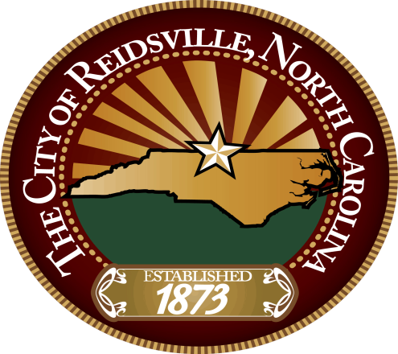

THE CITY OF REIDSVILLE
IS RECRUITING FOR THE POSITION OF
PLANNER I

Posted: JANUARY 13, 2020 through FEBRUARY 10, 2020
For information on the position and how to apply please visit:
https://jobs.reidsvillenc.gov/

