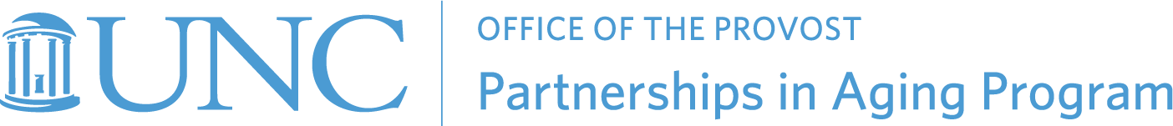

2022-2023 Undergraduate or Graduate Intern – Job Description

About the Partnerships in Aging Program: The Partnerships in Aging Program (PiAP) is a campus-wide program at The University of North Carolina Chapel Hill. In collaboration with organizations and institutions, we nurture dialogue about the personal and societal meaning of having a long life and advance civic engagement as a way to bring about a new kind of aging. PiAP provides expertise and resources to UNC faculty, students, and community partners seeking to reframe the aging experience, together.

Our Partner Organization: PiAP and the Marian Cheek Jackson Center have been collaborating over the last several years to develop aging-related initiatives in the Northside community and support student engagement with long-term residents.

About the Marian Cheek Jackson Center: The Jackson Center is a hub of creative action dedicated to preserving the future of historically Black neighborhoods in Chapel Hill and Carrboro, NC. Located in the heart of the Northside community, Center staff work in collaboration with Northside neighbors and friends to respect and to serve histories that, even as they are told, make new history out of Emancipation, Reconstruction, Jim Crow, civil rights struggle, and desegregation. Today Northside, Pine Knolls and Tin Top are among the most racially, ethnically, and economically diverse neighborhoods in the region.

About the Position: The partners seek an undergraduate or graduate intern who will support community engagement among students, older adults, and Northside community members by assisting with the administration and management of multiple programs including the Northside Residential Fellowship, the LINKing Generations in Northside program, and other developing aging initiatives (https://partnershipsinaging.unc.edu/current-initiatives/#LINK). Each of these initiatives centers the lived experience of older adults while mobilizing student engagement and everyday living to strengthen community ties and increase awareness of the history and present of Northside.

Responsibilities include but are not limited to:
- Communicate with students and team regularly regarding meetings, events, and program activities
- Send reminders and news regarding the community to team members and students
- Communicate with guest speakers and community mentors related to meetings
- Facilitate communication between fellows and Self-Help credit union related to any housing or lease related concerns
- Support meeting administration with agendas, minutes, and communication to members

Position Qualifications:
- An interest in community program development, oral histories, aging, housing justice, or community organizing, particularly in historically Black neighborhoods and communities
- Current UNC undergraduate (junior or senior) or graduate student
- Strong communication and organizational skills with attention to detail and follow-up
- Lived or professional experience building community in historically Black neighborhoods is not necessary, but highly valued

Position Details:
The intern will be mentored by a core team member from the Partnerships in Aging Program, Dr. Ryan Lavalley, who manages the associated programs. Although much of the work may be accomplished remotely, in-person meetings and events will be held at Marian Cheek Jackson Center and throughout the Northside Community.
Time commitment: Average of 3 hours/week.
Compensation is $15-20/hour depending on student experience.

To Apply:
Submit a resume and cover letter to Ryan Lavalley at ryan_lavalley@med.unc.edu and Cherie Rosemond (PiAP Director) at crosemon@med.unc.edu . Priority will be given to applications received by Sept. 16, 2022.

We welcome all qualified applicants. We strongly encourage applications from people who identify as Black or African American, indigenous, and other people of color, persons with disabilities, women, and LGBTQ applicants.

